WEBSITE WIREFRAME

ASSIGNMENT SUBMISSION COVER SHEET

Cse25-303
Student Id:

Oteng Monameng
Student names:
Cse25-303@thuto.bac.ac.bw
Student email:

Cohort: 2026

SCIS WMD_2026 A01
Assignment title:

20-03-2026
Date of submission:
Computer System Engineering
Programme of Study:

YEAR 1
Year of Study:

Intellectual property statement
By checking the box below, I certify that this assignment is my own work and is free from plagiarism. I understand that the assignment may be checked for plagiarism by electronic or other means and may be transferred and stored in a database for the purposes of data-matching to help detect plagiarism. The assignment has not previously been submitted for assessment in any other unit or to any other institution. I
have read and understood the Botswana Accountancy College plagiarism guidelines policy.
☐ Agree Signature…O.Monameng………………………………….
Date…………08-04-2026……………………………….

HOME PAGE
The home page is the entry point for Monameng Security Company website. It uses a linear information Hierarchy to guide the user from a visual feeling to understanding the business.

HEADER SECTION
Designed for immediate brand recognition and navigation. Logo and company name are on the left and centre to establish the identity of Monameng Security company immediately. The is a search bar on the right which ensures users find specific security information without scrolling. There is global navigation bar which contains links to all 10 pages and it follows 3-click rule.

HERO SECTION
The top of the page features a large Hero section. This area is reserved for a high-quality image representing the security industry. The purpose for this is to build immediate trust and provide a professional “first impression.”

MAIN SECTION (COMPANY DESCRIPTION)
Directly beneath the Hero section is the Company Description which is a short, concise summary of Monameng Security’s mission. I placed it in the main section to ensure that even if the user does not scroll down, they understand what services the company offers.

FOOTER SECTION
The bottom section is the footer, it provides important information like contact, copyright, legal and privacy. The footer is consistent across all web pages.

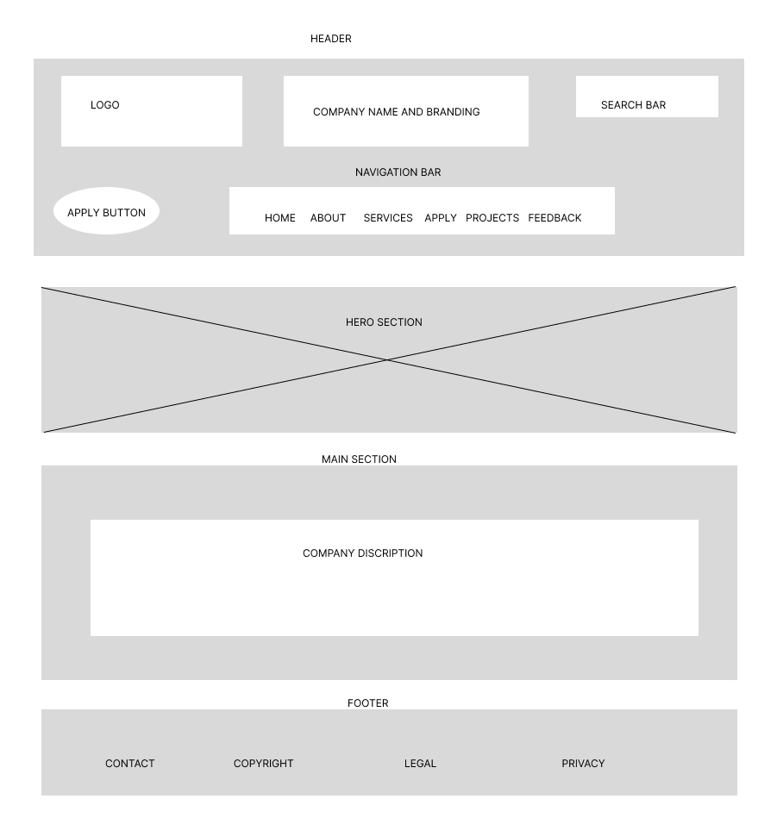
Figure 1:Home page

ABOUT PAGE
The about page is designed to transition the user from a general introduction to a deeper understanding of Monameng Security Company.

HEADER
Header remains identical to the Home page. In the navigation bar, about link is clearly defined as the active page helping users know where they are.

MAIN SECTION
It is broken into three blocks to create a clear Visual Hierarchy. There is the Company Profile block, and it’s the primary content. It establishes the “who” and “where” of the business. The

SIDEBAR
It consists of the face of the image placeholder. This image builds psychological connection of trust with the user. There is also a list of services offered which allows a user reading content on the about page to quickly jump to a specific service like alarms or CCTV without scrolling back to the main menu.

FOOTER
The bottom section is the footer, it provides important information like contact, copyright, legal and privacy. The footer is consistent across all web pages.

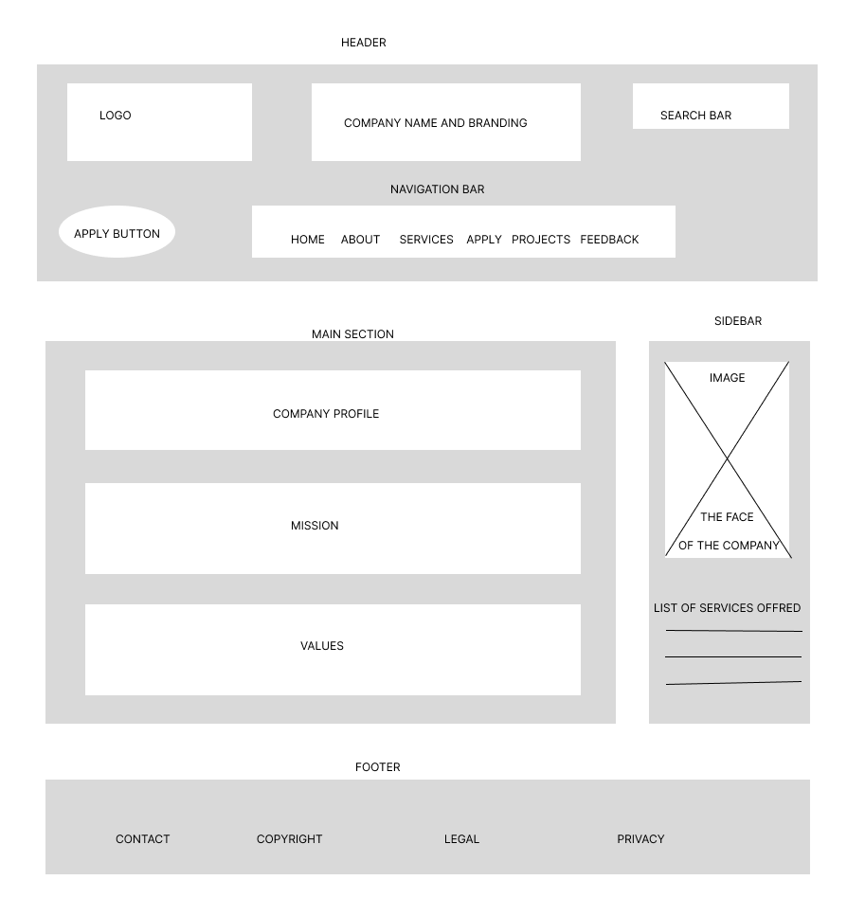
Figure 2:About page

SERVICES PAGE
The services page acts as a “menu” for the company offerings. The goal is to provide enough information a user to decide which security solution they need.

HEADER
The Header remains identical to the home and about pages. In the navigation bar the service link is clearly defined as the active page and the service link features a dropdown menu that will show the CCTV Installation, Armed response, Alarms, and Access control links for easy navigation.

MAIN SECTION
Here the services are organised into a grid. This allows the users to see all four offerings (CCTV Installation, Armed Response, Alarms, Access Control) at once. Each service block contains a brief summary about it allowing users to quickly find the service they are interested without reading long paragraphs and in addition there is a read more link for users who would like to read more about a specific service.

SIDEBAR
The sidebar on this page is used for Safety motivation. The supplementary content includes information about personal safety and ways to protect personal goods also to protect others.

FOOTER
The bottom section is the footer, it provides important information like contact, copyright, legal and privacy. The footer is consistent across all web pages.

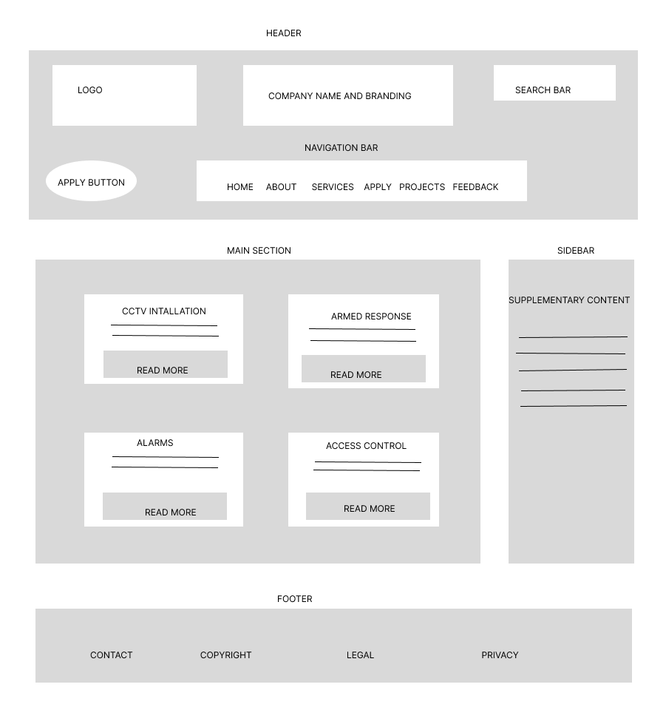
Figure 3:Services page

APPLY PAGE
The goal of the apply page is to allow users to allow users to perform an action of applying for a service they are interested and from there their application will be looked at by the company authority for the way forward.

HEADER SECTION
The Header remains identical to the Home, about and services page. In the navigation bar, the apply link is clearly defined as the active page helping users know where they are.

MAIN SECTION
The box represents active html form. It contains input fields like names, email, contact number, and a dropdown for a service required. The form is on the main page to avoid any distraction and making it easy for the user to complete the intended action.

SIDEBAR
It contains trust and help information. The text will include data privacy assurance since the user is sharing personal details, response guarantee, office opening and closing times and contact.

FOOTER SECTION
The bottom section is the footer, it provides important information like contact, copyright, legal and privacy. The footer is consistent across all web pages.
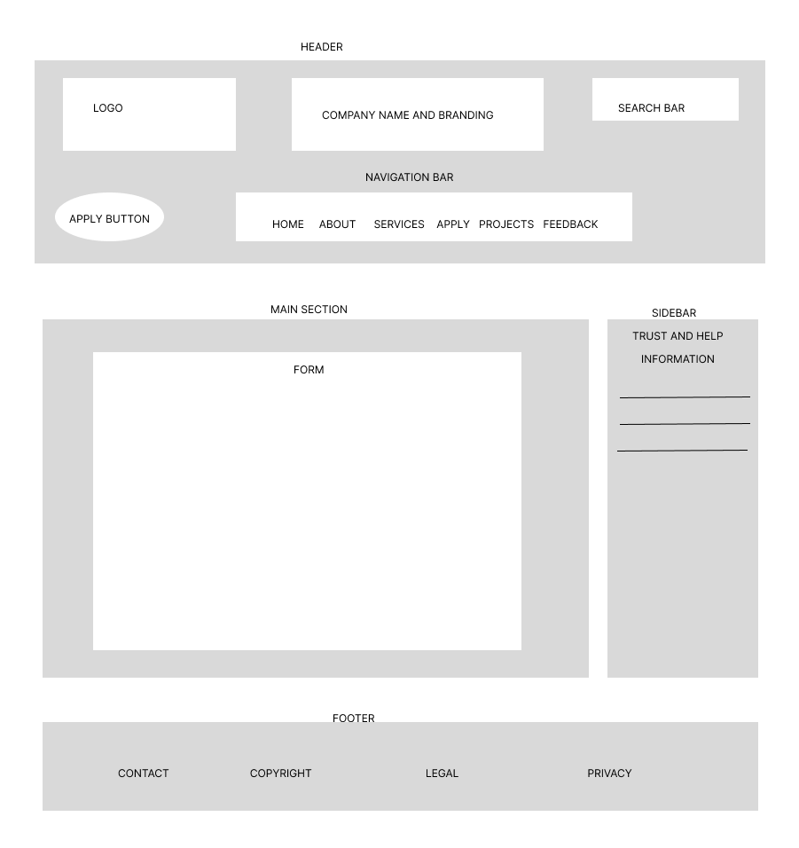
Figure 4:Apply page

PROJECTS PAGE
The project page is designed to showcase the real-world success of Monameng Security Company.

HEADER SECTION
The header is identical to all other pages.

MAIN SECTION
The section is divided into two blocks. Current Big Projects block area lists high level contracts like shopping mall. It establishes the company’s ability to handle large- scale security. This block focuses on smaller everyday wins like home alarm setups.

SIDEBAR
There is a safety advice in the side bar, instead of just selling the service, the site gives free tips on how to stay safe.

FOOTER
The bottom section is the footer, it provides important information like contact, copyright, legal and privacy. The footer is consistent across all web pages.

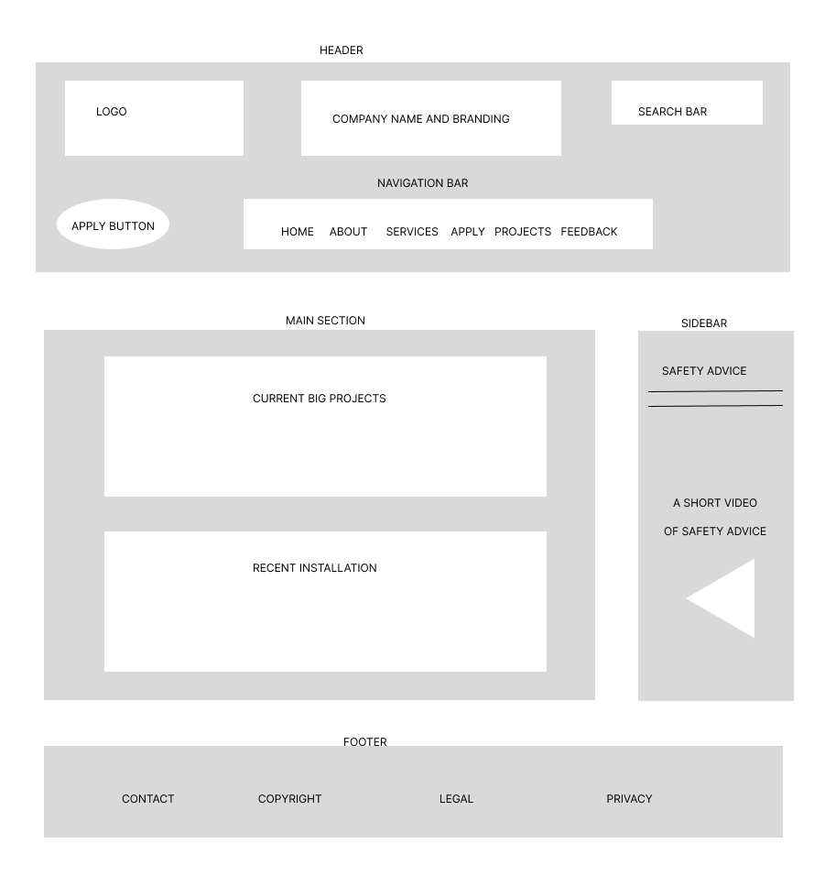
Figure 5:Projects page

FEEDBACK PAGE
The feedback is designed to facilitate communication between Monameng Security Company and it’s clients.

HEADER SECTION
The header is identical to all other pages.

MAIN SECTION
It contains the form that allow users to input their details and their rating the service and text area for comments. The form is on the main page to avoid any distraction and making it easy for the user to complete the action.

SIDEBAR
There is a safety advice in the side bar, instead of just selling the service, the site gives free tips on how to stay safe.

FOOTER
The footer remains consistent providing the same contact, copyright, legal, and privacy links found on all other links 9 pages.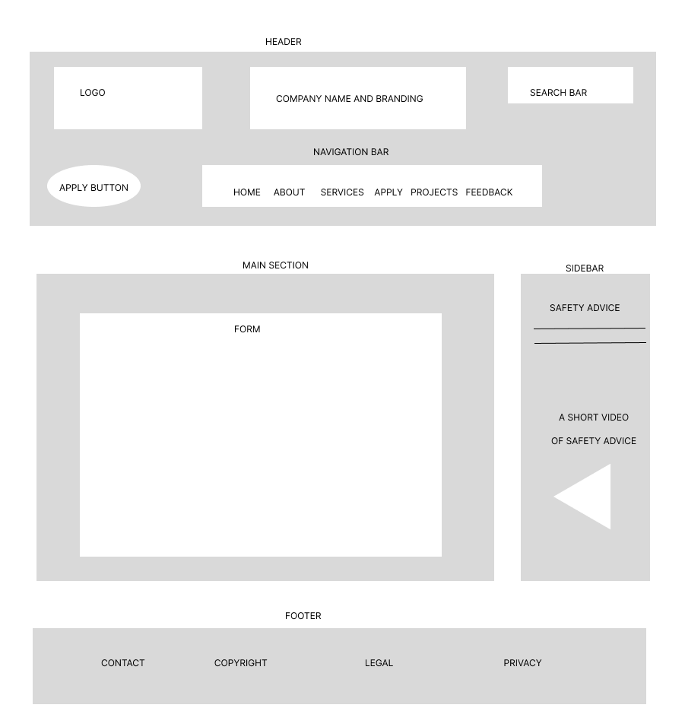
Figure 6:Feedback page

CCTV INSTALLATION PAGE
This is a specialised service detail page. It’s job is to move from general overview of the CCTV Installation in the service page to a more detailed information.

HEADER SECTION
The header is identical to all other pages. In the navigation under services the CCTV Installation link would be highlighted and this tell users where they are.

MAIN SECTION
This section is divided into two parts. There is a top layer which is a placeholder for a picture of CCTV cameras. Then there is a detailed information block which is reserved for technical specifications, benefits, and the installation process.

SIDEBAR
The sidebar is used for efficiency and inter-linking. It consists of list of other services which act as secondary navigation menu. If a user finishes reading about CCTV, he may realize that he also needs alarm service or any other service.

FOOTER
The footer remains consistent providing the same contact, copyright, legal, and privacy links found on all other links 9 pages.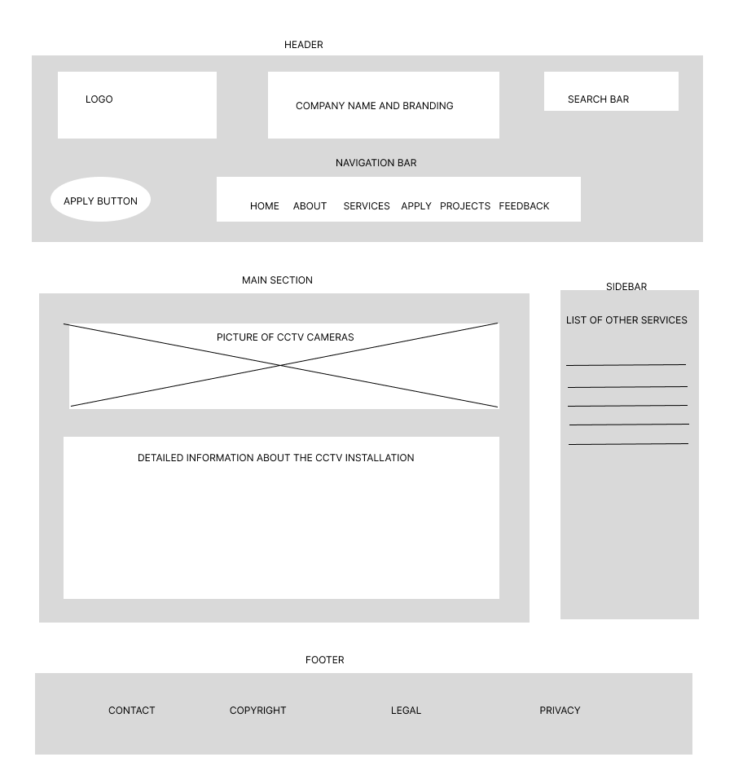
Figure 7:CCTV Installation page

ARMED RESPONSE
This is a specialised service detail page. The job of this page is to move from general overview of the armed response in the service page to a more detailed information.

HEADER SECTION
The header is identical to all other pages. In the navigation under services the armed response link would be highlighted and this tell users where they are.

MAIN SECTION
This section is divided into two parts. There is a top layer which is a placeholder for a video of Monameng Security Company armed team. Then there is a detailed information block which is reserved for technical specifications, benefits, and the installation process.

SIDEBAR
The sidebar is used for efficiency and inter-linking. It consists of list of other services which act as secondary navigation menu. If a user finishes reading about armed response, he may realize that he also needs alarm service or any other service.

FOOTER
The footer remains consistent providing the same contact, copyright, legal, and privacy links found on all other links 9 pages.

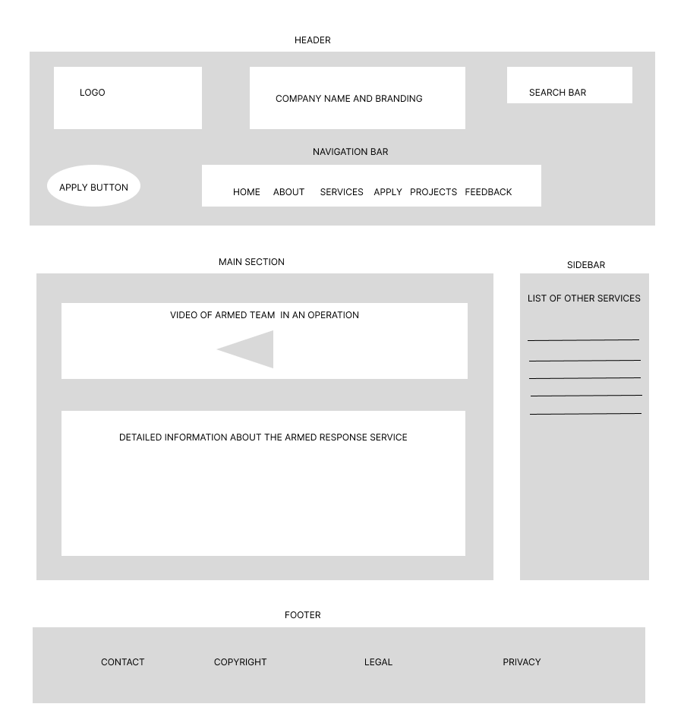
Figure 8:Armed response page

ALARMS PAGE
This is a specialised service detail page. The job of this page is to move from general overview of the alarms in the service page to a more detailed information.

HEADER SECTION
The header is identical to all other pages. In the navigation under services the alarms link would be highlighted and this tell users where they are.

MAIN SECTION
This section is divided into two parts. There is a top layer which is a placeholder for images of alarms offered by the company. Then there is a detailed information block which is reserved for technical specifications, benefits, and the installation process.

SIDEBAR
The sidebar is used for efficiency and inter-linking. It consists of list of other services which act as secondary navigation menu. If a user finishes reading about alarms, he may realize that he also needs CCTV Installation service or any other service.

FOOTER
The bottom section is the footer, it provides important information like contact, copyright, legal and privacy. The footer is consistent across all web pages.

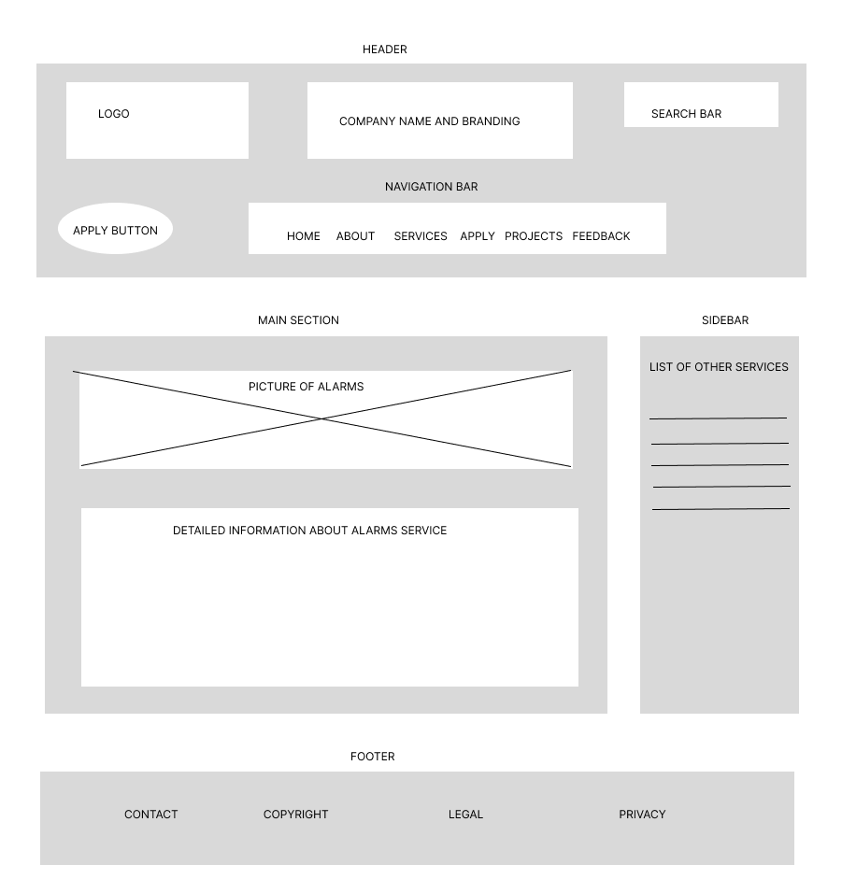
Figure 9:Alarms page

ACCESS CONTROL
This is a specialised service detail page. The job of this page is to move from general overview of the access control in the service page to a more detailed information.

HEADER SECTION
The header is identical to all other pages. In the navigation under services the access control link would be highlighted and this tell users where they are.

MAIN SECTION
This section is divided into two parts. There is a top layer which is a placeholder for image access control devices offered by the company. Then there is a detailed information block which is reserved for technical specifications, benefits, and the installation process.

SIDEBAR
The sidebar is used for efficiency and inter-linking. It consists of list of other services which act as secondary navigation menu. If a user finishes reading about access control, he may realize that he also needs CCTV Installation service or any other service.

FOOTER
The bottom section is the footer, it provides important information like contact, copyright, legal and privacy. The footer is consistent across all web pages.

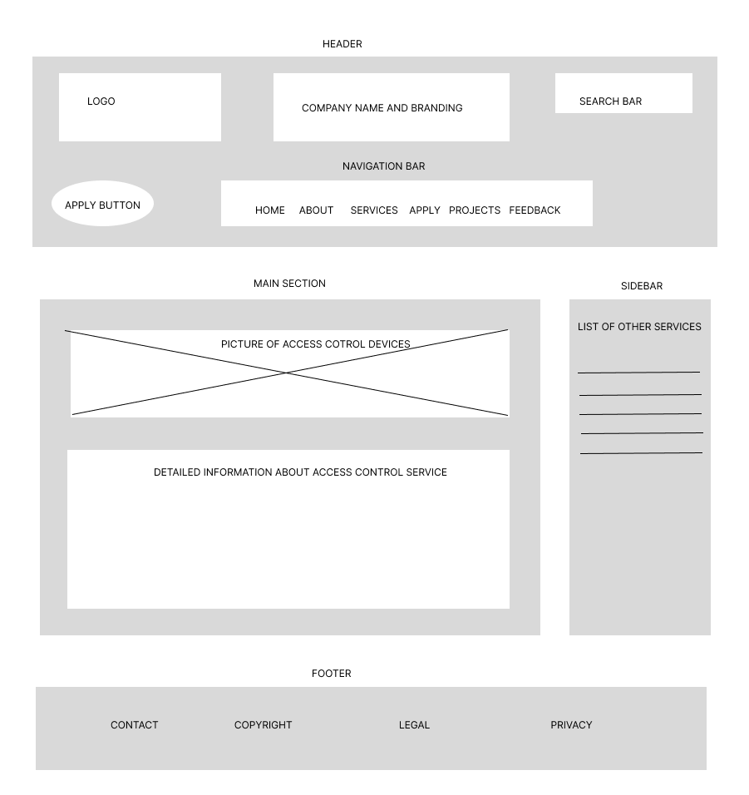
Figure 10:Access control page

